University of West London

School of Computing and Engineering
Project Progress Form 1 Module code: ___CP6SL46O____

Student Number: 33118842 |  | Submission Date: 05.08.2024
Student’s Surname: Mohamed Azher |  | Student’s Forename: Abdullah Aazam

Project Supervisor’s Name. Mahen Jayalath

Please note: Work presented for the project must be the student’s own. Plagiarism is where a student copies work from another source, published or unpublished (including the work of a fellow student) and fails to acknowledge the influence of another’s work or to attribute quotes to the author. Plagiarism is an academic offence.

I confirm this is my own work | Student's signature | 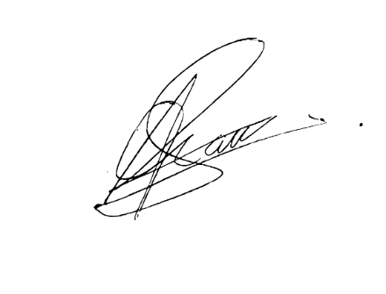

Project title
Development of a Mobile Application For Image Processing to Improve Environmental Recognition and Navigation for Blind People.

Progress made since project was approved
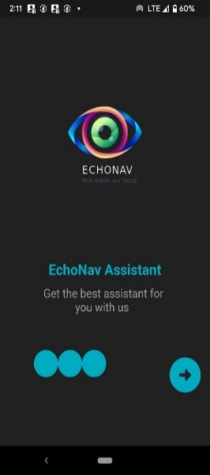
Created the flutter application with all the required libraries and dependencies. Then went throughout a research to identify most suitable pre-trained model for my project in tensorflow. There are plenty of modules available in tenserflow which is developed by different developers, then imported the models in my project and made a connection to the model and the application for it to work effectively without any crash or error. Tried futter build apk command to build the application and run the programme in mobile application unfortunately it crashes on home page of the application. All relevant logo and into screen has been developed, theme colour, intro slogan, voice command and voice connection to the application too implemented.
This the design for the intro screen and one it starts the application’s voice assistance will be guiding you to start the application by saying “swipe right to start the application throughout voice commands”.

List of meeting dates with supervisor (to be completed by student)

Comments and further actions (to be completed by supervisor before submission)

 | 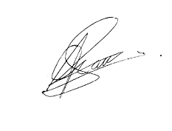  Signatures | Date
Student
Supervisor
(before submission)

University of West London

School of Computing and Engineering
Project Progress Form 2 Module code: ___CP6SL46O____

Student Number: 33118842 |  | Submission Date: 05.18.2024
Student’s Surname: Mohamed Azher |  | Student’s Forename: Abdullah Aazam

Project Supervisor’s Name. Mahen Jayalath

Please note: Work presented for the project must be the student’s own. Plagiarism is where a student copies work from another source, published or unpublished (including the work of a fellow student) and fails to acknowledge the influence of another’s work or to attribute quotes to the author. Plagiarism is an academic offence.

I confirm this is my own work | Student's signature

Project title
Development of a Mobile Application For Image Processing to Improve Environmental Recognition and Navigation for Blind People.

Progress made since project was approved
As I mentioned last time in my previous progress report. The app used to crash after the loading screen, the issue is fixed and all the modules were imported properly. The error that I encountered is a build cache. Which is usually all developers encounter while developing the app. Some cache do store in our local computer. So I fixed this error by giving the flutter clean which deletes all the dependencies and clean the project. Then again used the flutter pub get command to reinstall the dependencies and packages. Then tried converting it again to an apk and tried in a google pixel 3 phone and it works well.
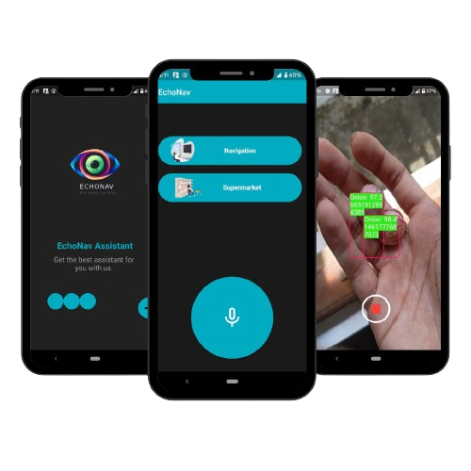
This is a overview screen shot of the application running in a android device. Here I included the video link for the evidence that the application works well without any error. (https://youtu.be/7ngiIXdEISA?si=WmixEQQ5bUG3bi4f)

Note: In the above video you might encounter a voice difference from the voice assistance its because for the device I use. The system voice works fine in both virtual and other devices only in my device I do have a voice change which is a error in device not in the system.

List of meeting dates with supervisor (to be completed by student)

Comments and further actions (to be completed by supervisor before submission)

 | Signatures | Date
Student
Supervisor
(before submission)

